**Project Report Template**

**A CRM APPLICATION FOR SCHOOL/COLLEGES**

1. **Introduction:**
   1. Overview

The project aim is to provide real-time knowledge for all the students who have basic knowledge of Salesforce and Looking for a real-time project. This project will also help those professionals who are in cross-technology and want to switch to Salesforce. With the help of this project theymwill gain knowledge and can include it into their resume as well.

* 1. Purpose

Using a CRM system provides educational organisation with the data they need to make informed decisions about recruitment, marketing, and other key areas. It also allows you to improve student engagement by tracking student interactions and providing personalised communication.

1. **Problem Definition & Design Thinking**
   1. Empathy Map

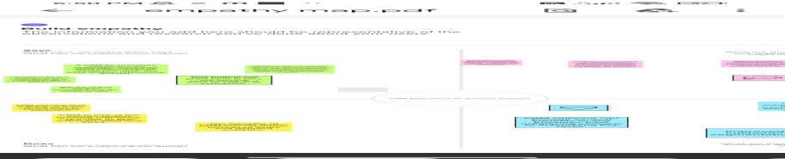

* 1. Ideation and Brainstorming Map

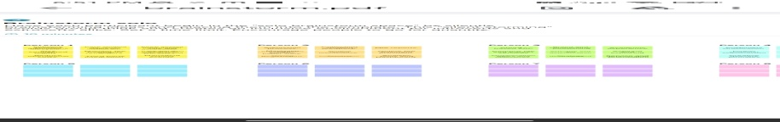

1. **Result**

**3.1** Data Model

| **Object** | **Field label** | **Data type** |
| --- | --- | --- |
| School | Address  Phone Number  Number of Students  Highest mark | Text area  Phone  Roll-up summary  Roll-up summary |
| Student | Phone-Number  School  Results  Class | Phone  Master-detail relationship  Picklist  Number |
| Parent | Parent Address  Parent Address | Text Area  Phone |

**3.2** Activity & Screenshot

We done empathy map and brain storming and uploaded in Github. Alos we done the trailhead badges completion and earn points.

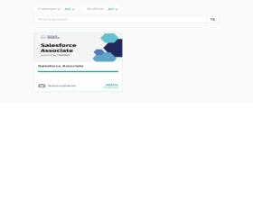 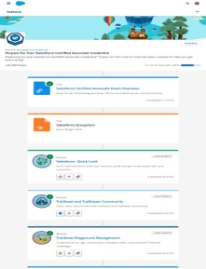 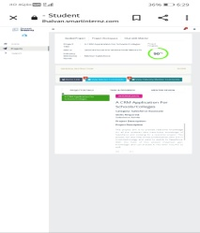

1. **Trailhead Profile Public URL**

Team Lead :https://trailblazer.me/id/ddarshini9

Team Member 1: https://trailblazer.me/id/gsurya52

Team Member 2: https://trailblazer.me/id/dhart243

Team Member 3: <https://trailblazer.me/id/pgayathri30>

1. **Advantages & Disadvantages**

Advantages

* Personalised communication
* Improved enrolments
* Lead management
* Increased revenue
* Automated communication

Disadvantages

* Record less
* Overhead
* Technical support
* Security issues

1. **Applications**

* Banking
* Education
* Insurance and Health care

1. **Conclusion**

Salesforce can be used to manage orders from retail stores and distributions, including tracking orders, processing payments, and managing inventory levels.

1. **Future Scope**

CRM as a single source of truth, more and deeper automations, customer intelligence is king, keeping customers happy keeps them coming back.